JULY 2018

Dear Owner/Manager,

We would like to take this opportunity to introduce our club to you. REACH is a club where friendships are made and lives are enriched through everyday interactions. The concept is simple, yet life changing. Live Oak High students have the opportunity to set an example by embracing an inclusive environment within our school and community. Being a part of REACH provides an experience that promotes friendships among people with and without disabilities. It is an opportunity to learn about one another, accept one another, and to set a high standard of acceptance among our student body. We would like for you to be a part of the movement!

We are currently planning our 3rd annual REV IT UP for REACH car, truck, and bike show to be held on Saturday, July 21st at Live Oak High School. Our events are always family friendly, and will bring lots of very nice custom cars and trucks, hot rods, antique vehicles and other special interest vehicles for display in our community.

In order to have a successful event we would like to solicit items from your business for door prizes which will be handed out to participants of the cruise-in. Some examples of items we are looking for are, anything automotive such as fender covers, hand cleaner, hand tools, discount coupons that would bring the participants of our cruise-in to your establishment.

You can also elect to sponsor with a monetary donation of $25, $50, $75, or $100. With your help, the 3rd annual REV IT UP for REACH car, truck, and bike show will be as successful as the last two have been.

Thank you for your consideration into contributing to LIVE OAK REACH!

Sincerely,

Live Oak High
REACH Club

3rd Annual
REV It Up for REACH
Car, Truck, and Bike Show!
Sponsor or Donation Form

Sponsor Name:____________________________________________________________
Address: _________________________________________________________________
City, St, ZIP; ______________________________________________________________
Phone:___________________________________________________________________
Website: _________________________________________________________________
Contact Name: ____________________________________________________________
Email: ___________________________________________________________________

Sponsorship $25, $50, $75, $100 (Circle the amount given)
Or
Item Donation_________________________________________________ (Description)

Received by: ________________________________________(REACH club member)

(tear here)---------------------------------------------------------------------------------------------------------------

Receipt for Sponsorship or Donation
Received From (Sponsor Name):__________________________________________________

Amount: $_____________
or
Item Donation Description: ______________________________________________________

Signed: ______________________________________Date: ___________________________

(REACH Club Member) __________________________________________________

Thank You, for your Support and Participation of the 3rd Annual Rev It Up for REACH Car, Truck, and Bike Show!
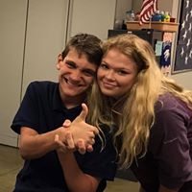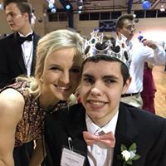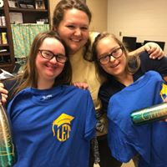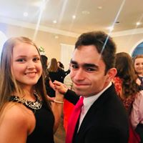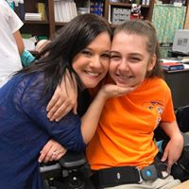
Respect Everyone And Create Harmony
Be Together, Not The Same

