Live Oak High
Standing up for yourself is IMPORTANT, Standing up for someone else is MORE IMPORTANT, Standing WITH someone is MOST IMPORTANT.
Presents
Visit www.liveoakreach.com for more information about REACH club!!
3rd Annual
“Rev It Up” For REACH
Car Show
(Cars, Trucks, & Motorcycles Welcome)
Saturday, July 21nd, 2018
10AM-1:30PM (Awards)
Come inside the gym to cool off and check out the vendors!
At Live Oak High School
36079 LA Hwy 16 Denham Springs, LA 70706
PRE-REGISTRATION until July 19th, 2018 ON-SITE REGISTRATION
Includes Meal Ticket Includes Meal Ticket
Online Registration $25 Onsite Registration $30

- FREE 11 by 17 Picture Poster of your vehicle if on-site before 11:00AM
- Goody bags for first 150 cars and free entry into door prizes for all registrants
- AWARDS at 1:30PM
TOP 25, Best Paint, Best Interior, Best Engine, Best Car, Best Truck, Best Motorcycle, and REACH CLUB CHOICE
50/50 RAFFLE, DOOR PRIZES, VENDORS & GOOD MUSIC!!
Jambalaya, Drinks, & MORE!!!
ALL PROCEEDS BENEFIT THE REACH CLUB OF LIVE OAK HIGH SCHOOL

_____________________________________________________________________________________
To register ONLINE go to the following link:
https://osp.osmsinc.com/LivingstonLA
Click “High School” then “Live Oak High”
From there, you will register online.
You will need to create an account (takes 5 seconds) before you will be able to check out.

Please bring a completed registration form with you the day of the event.
3rd Annual “Rev It Up” for REACH
Registration Form

Name: ___________________________________________________________________
Address: ___________________________________________________________________
City: ________________________State: __________Zip:____________
Phone: _________________
Make: ___________________________________
Model: ____________________Year: __________

EMAIL: ___________________________________________________________
Contacts: Donald Trahan at 225-938-8434 or Jessica Bonura at Jessica.bonura@lpsb.org
REACH
Respect Everyone and Create Harmony

At Live Oak High and in our community, we believe in nurturing an environment where people of ALL abilities are welcome, embraced, and encouraged to soar! REACH is a club that is quickly growing in our parish. REACH is committed to breaking down barriers and forming lifelong friendships among people with and without disabilities. It is with YOUR support that we are making a positive difference in our school, community, and parish. Thank you!
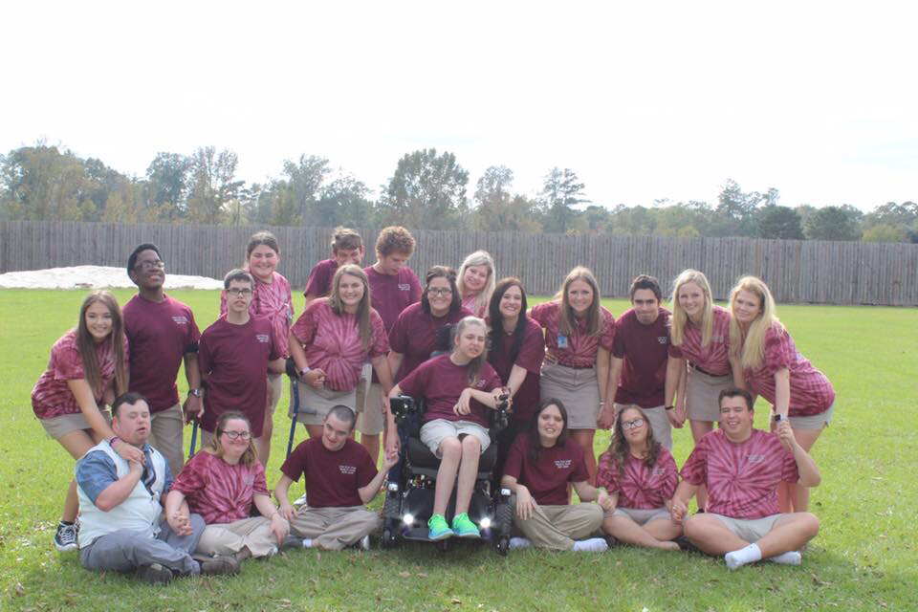

“BE TOGETHER NOT THE SAME”

